**DV Bridal Academy**

Project Report

Website

Submitted in partial fulfillment of requirements for the award of the degree

BACHELOR OF TECHNOLOGY

In

INFORMATION TECHNOLOGY

BY

S.Ragavi

**1**

**Contents**

| **sno** | **Title** | **Pageno** |
| --- | --- | --- |
| **1.** | Abstract | **3** |
| **2.** | Introduction | **4** |
| **3.** | Requirements and Specifications | **6** |
| **4.** | Design | **7** |
| **5.** | Implementation | **10** |
| **6.** | Conclusion | **57** |

**2**

**ABSTRACT:**

The Project is developed by using HTML,CSS,JavaScript as Front end and MY SQL Server as Back end,the connecting Middleware is Java.The Dv bridal academy website having login and signup page for users to create their own account for bridal courses.User can also register classes through registration form.we can also fix appointment for bridal makeup in any event.We have contact details for interaction , services from Dv Bridal academy and done works.The Courses we provide is Bridal makeup,hairstyling,Saree Draping.we can make appointment from the website.

**3**

**INTRODUCTION**

**OVERVIEW OF PROJECT:**

The system was intended to develop a website to provide Dv bridal academy services to users. So we can easily access and register for ourselves for any event or course registration.it will be useful for time consumption, man power and also making the process so fast, portable and simple.

**1.2 OBJECTIVE AND SCOPE OF THE PROJECT:**

This Project’s objective is to provide a simple and fast way of making appointments and registering for courses online which is a tedious manual process where man power, lots of time are needed.

A,User login,

B, Sign Up,

C, Bridal Course Registration,

D,Making Appointment

**1.3 Project Profile:**

Project Name: DV Bridal Academy

Developed in: Website

Front End: HTML, CSS, Javascript

Middleware: Java

Back end: My SQL

Documentation Tool: MS Word

**4**

**1.4 TECHNOLOGY REVIEW:**

The technologies implemented in developing this website are,

**1.4.1 HTML & CSS:**

HTML is used to create web based documents that are being displayed on the WWW (World Wide Web). Each page contains a series of connections to other pages as hyperlinks. Every web page you see on the net is written using a version of HTML codes. HTML code ensures the proper formatting of text and images so that the web browser may display them as they are intended to look. Without HTML, a browser would not know how to display text as an element or load images or other elements. HTML also provides a basic structure of the page, upon which CSS (Cascading Style Sheets) are overlaid to change the appearance of the web pages. One could think of HTML as the structure of a web page, and CSS as its overall design pattern.

**1.4.2 MYSQL:**

MySQL is an Oracle-backed open source (RDBMS) Relational Database Management System based on Structured Query Language. My SQL runs virtually on all platforms. My SQL enables data to be stored and accessed across multiple storage engines. For security, My SQL uses an access privilege and encrypted password system that enables host-based verification. MySQL clients can connect to MySQL Server using several protocols, including TCP/IP sockets on any platform.

**1.4.3 Javascript:**

JavaScript is a text-based programming language used both on the client-side and server-side that allows you to make web pages interactive. ... Incorporating JavaScript improves the user experience of the web page by converting it from a static page into an interactive one. To recap, JavaScript adds behavior to web pages.

**5**

**1.5 REQUIREMENT SPECIFICATIONS:**

The specifications define the system requirements and the user requirements.

**1.5.1 USER REQUIREMENTS:**

On analysing the user requirements there came a conclusion that they need portable, less time consuming, easy and simple way of accessing the system, which is analysed and taken into account as a result this project is being developed in such a way in providing easy access to both the admin and the users.

**1.5.2 SYSTEM REQUIREMENTS:**

This requirement is further divided as functional and non functional requirements.

**1.5.3 FUNCTIONAL REQUIREMENTS**

* User registration
* Login & Signup
* Making Appointment

**1.5.4 NON FUNCTIONAL REQUIREMENTS:**

The non –Functional requirement provides the user the additional functionality of the systems capability and availability, this project provides the user with the availability of the services 24/7 hrs/days.

**6**

**DESIGN**

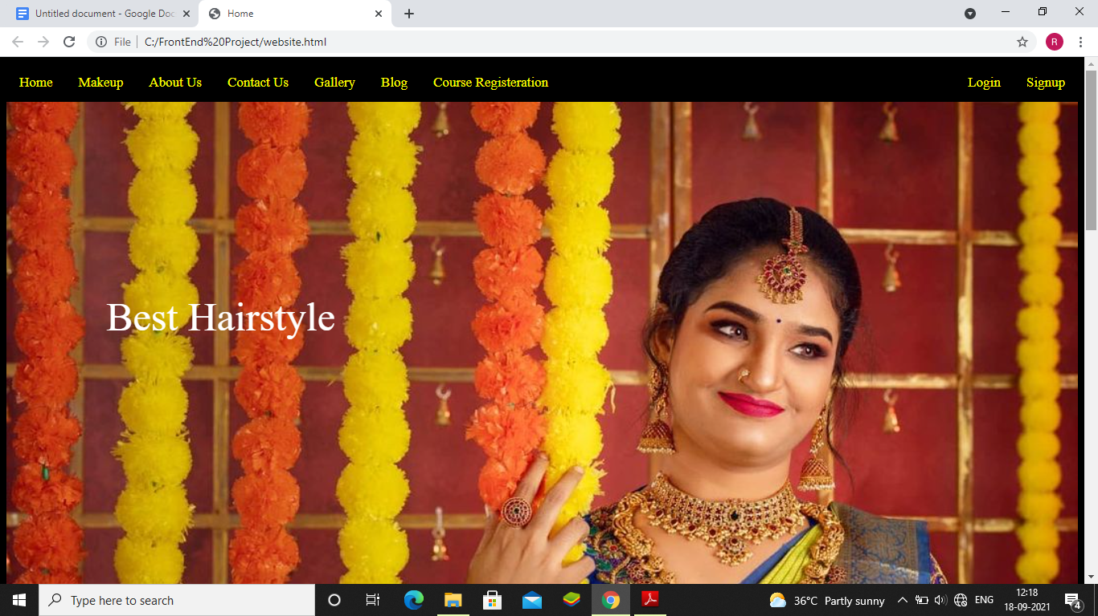

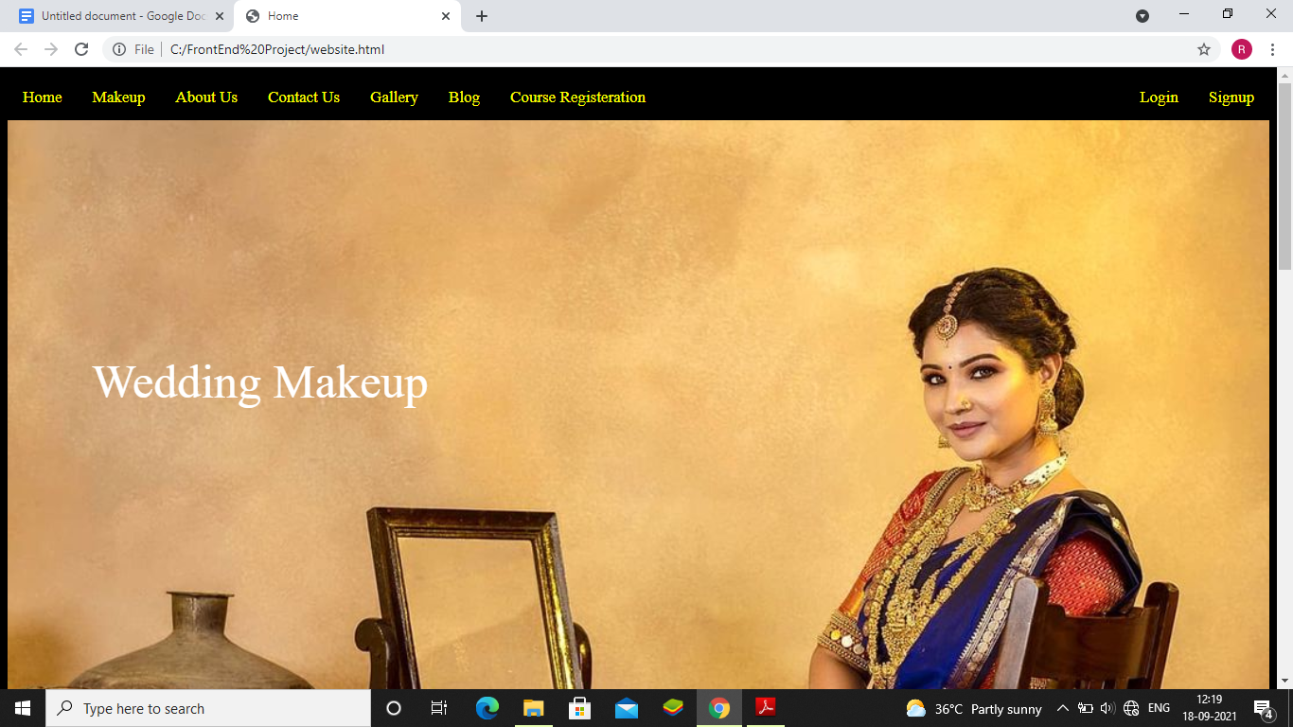

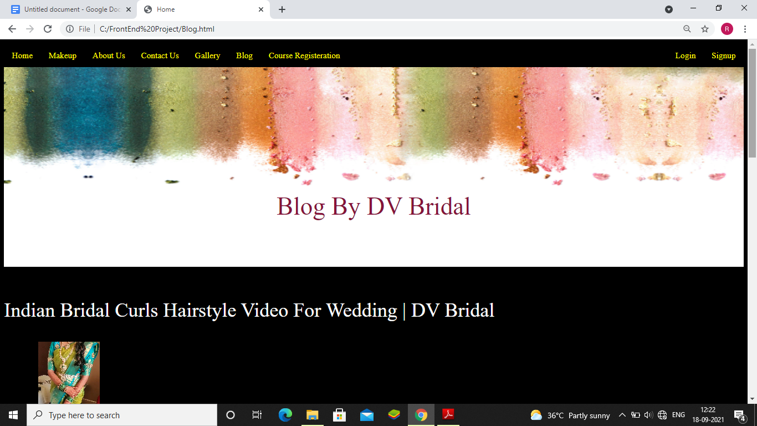

**Course registeration:**

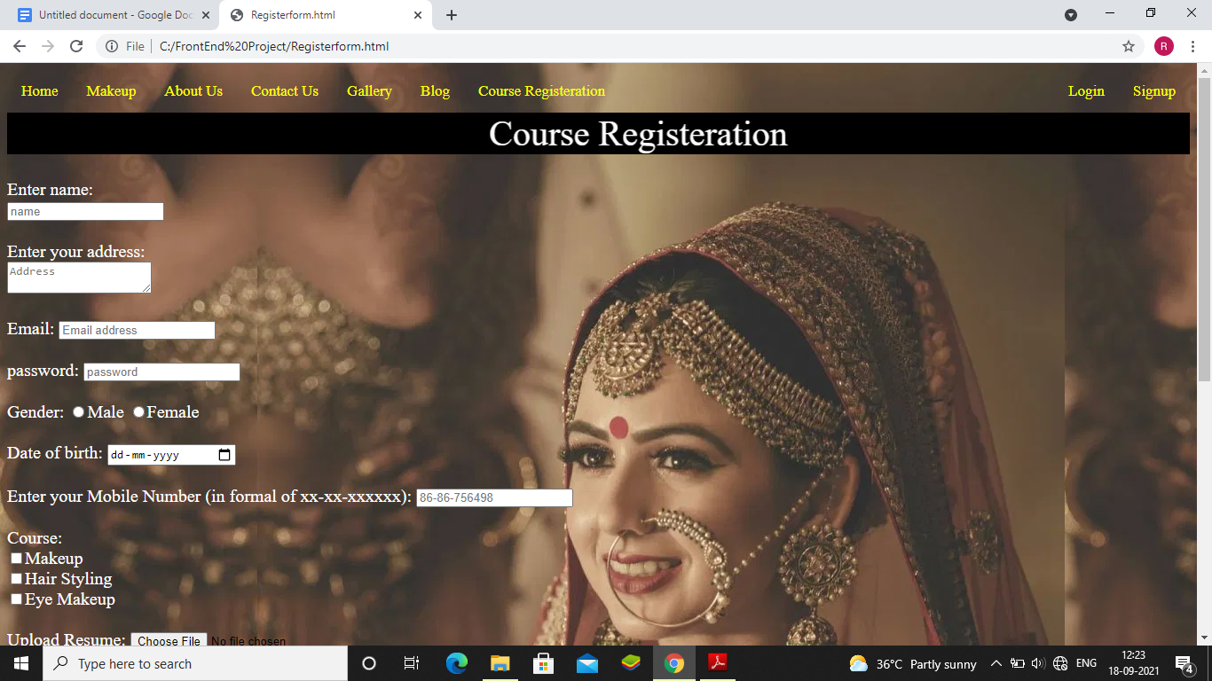

**Login:**

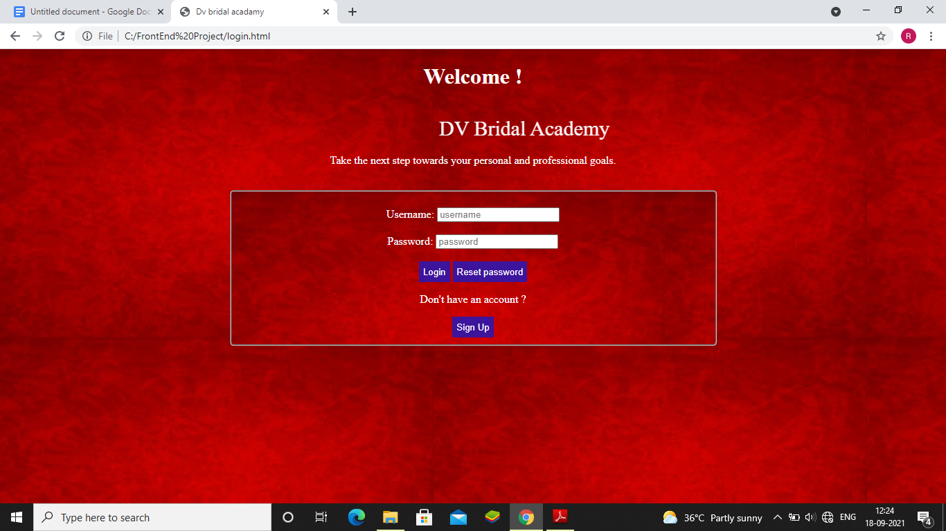

**Signup:**

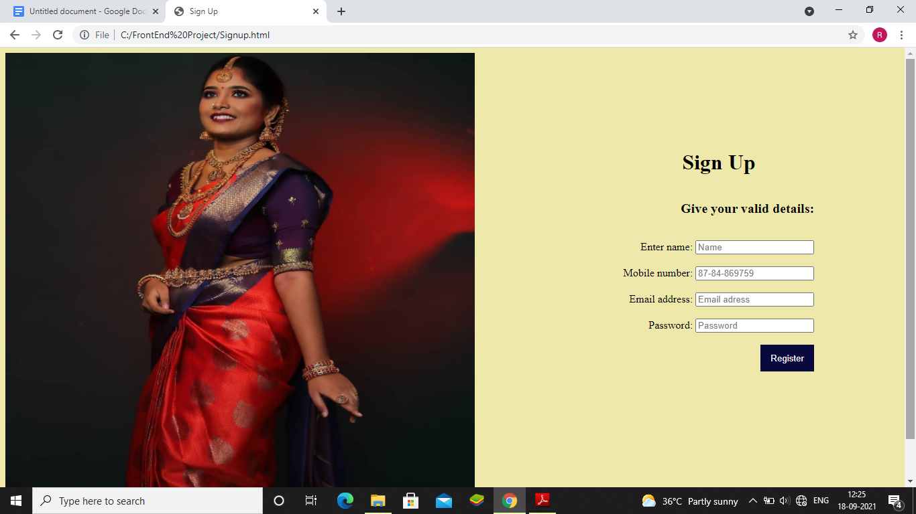

**Appointment :**

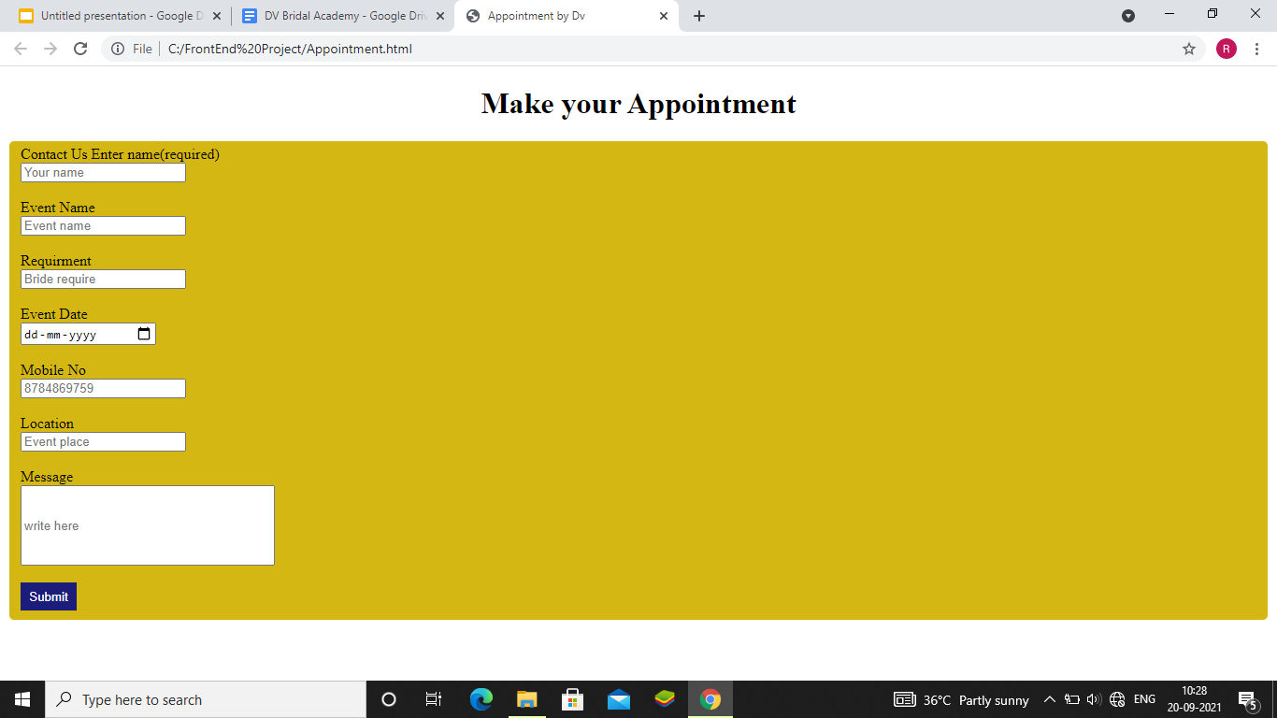

**Implementation**

**Source code:**

**Html,Css,Js code:**

**Website.html:**

<!DOCTYPE html>

<html lang="en">

<head>

<meta charset="UTF-8">

<meta http-equiv="X-UA-Compatible" content="IE=edge">

<meta name="viewport" content="width=device-width, initial-scale=1.0">

<title>Home</title>

<style>

body{

background-color: black;

}

.topnav {

overflow: hidden;

background-color:black;

}

.topnav a {

float: left;

color: yellow;

text-align: center;

padding: 14px 16px;

text-decoration: none;

font-size: 17px;

}

.topnav a:hover {

background-color: #ddd;

color: black;

}

/* Slideshow container */

.slideshow-container {

max-width: 100%;

position: relative;

margin: auto;

}

/* Caption text */

.text {

position: absolute;

font-size: 50px;

font-family: Times Romen;

color: white;

top: 30%;

left: 20%;

transform: translate(-50%, -50%);

}

.text1 {

position: absolute;

font-size: 50px;

font-family: Times Romen;

color:white;

top: 30%;

left: 20%;

transform: translate(-50%, -50%);

}

.text2 {

position: absolute;

font-size: 50px;

font-family: Times Romen;

color:white;

top: 30%;

left: 20%;

transform: translate(-50%, -50%);

}

/* The dots/bullets/indicators */

.dot {

height: 15px;

width: 15px;

margin: 0 2px;

background-color: #bbb;

border-radius: 50%;

display: inline-block;

transition: background-color 0.6s ease;

}

.active {

background-color: #717171;

}

/* Fading animation */

.fade {

-webkit-animation-name: fade;

-webkit-animation-duration: 1.5s;

animation-name: fade;

animation-duration: 1.5s;

}

p{

color: white;

}

button,button1,button3{

background-color: rgb(192, 192, 27);

color: white;

border: none;

height: 30px;

cursor: pointer;

}

.set{

border:none;

background-color: rgb(255, 235, 205);

}

.makeup{

color: black;

text-align: center;

}

.caption-container {

text-align: center;

position: relative;

background-color: #222;

padding: 0.px 16px;

font-size: 25px;

color: white;

}

.row:after {

content: "";

display: table;

clear: both;

}

/* Six columns side by side */

.column {

float: left;

width: 16.66%;

}

/* Add a transparency effect for thumnbail images */

.demo {

opacity: none;

}

.active,

.demo:hover {

opacity: 1;

}

.footer{

background-color: black;

color: white;

}

li {

display:inline;

padding: 100px;

}

#menu {

margin: 16px 0px 16px 0px;

}

.footer{

background-color: black;

color: white;

}

</style>

</head>

<body>

<div class="topnav">

<a href ="home.html">Home</a>

<a href ="Makeup.html">Makeup</a>

<a href ="About Us.html">About Us</a>

<a href ="Contact us.html">Contact Us</a>

<a href="Gallery.html">Gallery</a>

<a href="Blog.html">Blog</a>

<a href="Registerform.html">Course Registeration</a>

<div style=float:right><a href="Signup.html">Signup</a></div>

<div style=float:right><a href ="login.html">Login</a></div>

</div>

<div class="slideshow-container">

<div class="mySlides fade">

<img src="C:\Users\ELCOT\Pictures\136679908_426146965189820_3215951687600547083_n.jpg" style="width:100%">

<div class="text">Wedding Makeup</div>

</div>

<div class="mySlides fade">

<img src="C:\Users\ELCOT\Pictures\150526342_746170089362566_1268463751818361708_n.jpg" style="width:100%">

<div class="text1">Highlight The Best In U</div>

</div>

<div class="mySlides fade">

<img src="C:\Users\ELCOT\Pictures\134564195_352234309554979_4577035457145142561_n.jpg" style="width:100%">

<div class="text2">Best Hairstyle</div>

</div>

</div>

<br>

<div style="text-align:center">

<span class="dot"></span>

<span class="dot"></span>

<span class="dot"></span>

</div>

<script>

var slideIndex = 0;

showSlides();

function showSlides() {

var i;

var slides = document.getElementsByClassName("mySlides");

var dots = document.getElementsByClassName("dot");

for (i = 0; i < slides.length; i++) {

slides[i].style.display = "none";

}

slideIndex++;

if (slideIndex > slides.length) {slideIndex = 1}

for (i = 0; i < dots.length; i++) {

dots[i].className = dots[i].className.replace(" active", "");

}

slides[slideIndex-1].style.display = "block";

dots[slideIndex-1].className += " active";

setTimeout(showSlides, 2000); // Change image every 2 seconds

}

</script>

<form>

<p>

DV Bridal Academy

Love For Beauty Is Taste And Creation Of Beauty Is An Art

Personal Grooming Course

This course is specially designed for today’s smart woman or orientated working women who have no time, yet want to upgrade her personal image according to her own lifestyle at her own convenience. It’s the ultimate learning environment for learning how to look more beautiful, therefore boosting her self esteem and confidence. You will be explained the easy every day makeup techniques along with the hands on practice with makeup.<br></p>

<center><button class="button" name="Know more" formaction="About Us.html">Know More</button></center><br><br>

<p>Professional Make-Up Course

This 5 week comprehensive course will take you from a basic make up application to an advanced makeup specialist level. Our course is taught by an experienced makeup artist DivyaVinu herself. Each day during this course you will learn a large variety of tips and tricks that will enhance your bridal on her special day. You will go over a wide range of product and learn what to use in order to achieve the ideal make up look for your client.<br></p><center>

<button class="button1" formaction="Blog.html" >Know More</button></center><br><br>

<fieldset class="set">

<h1 class="makeup">Makeup By DV Bridal</h1>

<div class="caption-container">

<p id="caption"></p>

</div>

<div class="row">

<div class="column">

<img class="demo cursor" src="C:\Users\ELCOT\Pictures\140054239_227263848985058_6160239565378782810_n.jpg" style="width:100%" onclick="currentSlide(1)" alt="Muhurtham Makeover">

</div>

<div class="column">

<img class="demo cursor" src="C:\Users\ELCOT\Pictures\159959582_905273096680997_3729417944746867359_n.jpg" style="width:100%" onclick="currentSlide(2)" alt="Bride">

</div>

<div class="column">

<img class="demo cursor" src="C:\Users\ELCOT\Pictures\118407022_533741460724797_7225417329734124846_n.jpg" style="width:100%" onclick="currentSlide(3)" alt="Reception Makeover">

</div>

<div class="column">

<img class="demo cursor" src="C:\Users\ELCOT\Pictures\118040250_339868490473759_6023134407961009340_n.jpg" style="width:100%" onclick="currentSlide(4)" alt="Traditional Look">

</div>

<div class="column">

<img class="demo cursor" src="C:\Users\ELCOT\Pictures\118298756_120941416148154_4402811179566374760_n.jpg" style="width:100%" onclick="currentSlide(5)" alt="Reception Makeover">

</div>

<div class="column">

<img class="demo cursor" src="C:\Users\ELCOT\Pictures\135759128_218011826600525_2341138053846840673_n.jpg" style="width:100%" height="220px" onclick="currentSlide(6)" alt="Muhurtham">

</div>

</div><br>

<center><button class="button3" formaction="Makeup.html" >Know More</button></center>

</fieldset><br><br>

<footer class="footer">

<fieldset>

<h1 style="color: gold">DV bridal</h1>

<p style="color:white">DV Bridal Provide to the modern Indian woman <br>a plethora of beauty and grooming services with <br>its repertoire of professional beauticians and stylists.<br><br>

+91 9811296961<br>

+91 9811296971<br><br>

F 19/3, sector-8, Keelkattalai,<br>

Near Bus Stand,<br>

Chennai -600026, India.<br>

</p>

<hr>

<p>Privacy policy | Cookie policy | Do Not Sell My Personel Information | Terms Made with in NYC @2021 DV Bridal </p>

</fieldset>

</footer>

</form>

</body>

</html>

**About us.html:**

<!DOCTYPE html>

<html lang="en">

<head>

<meta charset="UTF-8">

<meta http-equiv="X-UA-Compatible" content="IE=edge">

<meta name="viewport" content="width=>, initial-scale=1.0">

<title>Document</title>

<style>

body{

background-color: black;

}

.topnav {

overflow: hidden;

background-color: black;

}

.topnav a {

float: left;

color: yellow;

text-align: center;

padding: 14px 16px;

text-decoration: none;

font-size: 17px;

}

.topnav a:hover {

background-color:#ddd;

color: black;

}

.text {

color: black;

font-size: 50px;

font-style: italic;

padding: 50px 50px;

position: absolute;

bottom: 8px;

width: 100%;

text-align: center;

}

p,h1{

color: white;

}

.footer{

background-color: black;

color: white;

}

</style>

</head>

<body>

<div class="topnav">

<a href ="home.html">Home</a>

<a href ="Makeup.html">Makeup</a>

<a href ="About Us.html">About Us</a>

<a href ="Contact us.html">Contact Us</a>

<a href="Gallery.html">Gallery</a>

<a href="Blog.html">Blog</a>

<a href="Registerform.html">Course Registeration</a>

<div style=float:right><a href="Signup.html">Signup</a></div>

<div style=float:right><a href ="login.html">Login</a></div>

</div>

<div class="image">

<img src="C:\Users\ELCOT\Pictures\118298756_120941416148154_4402811179566374760_n.jpg" width="100%" height="600px" alt="bride">

<div class="text">About Us</div>

</div>

<p> DV is an upmarket beauty salon with ample services to create magnificent makeovers. We offer world class beauty services and run an academy to teach the art of make-up and styling. The reputation and response that Krushhh has earned in the past couple of years is synonymous with the big names in the industry.<br><br>

Over a period of time the evolution of make-up has undergone a huge change. Since, no one can actually say when this art was developed, history reveals people have been using make-up from centuries ago. The tombs of Egyptians reveal they had being using make-up been before 3000 BC! Humans have always wanted to look better or rather the best.</p>

<h1>“A woman without paint is like food without salt” – Plautus</h1>

<p>In today’s era a woman has plenty of options to choose from, the market is flooded with beauty products. But then, are all products safe? Some of these can cause a potential threat to an individual’s skin. Ergo, we pay utmost attention to the products and equipment we use. Premium quality, branded, natural product are used by us so that their skin is unharmed.

We at Dv aim to highlight the features of our clients and hide their imperfections to make them look perfect.

We offer complete beauty care services, hair, , make-up and more.<br><br>

</p><br><br>

<footer class="footer">

<fieldset>

<h1 style="color: gold">DV bridal</h1>

<p style="color:white">DV Bridal Provide to the modern Indian woman <br>a plethora of beauty and grooming services with <br>its repertoire of professional beauticians and stylists.<br><br>

+91 9811296961<br>

+91 9811296971<br><br>

F 19/3, sector-8, Keelkattalai,<br>

Near Bus Stand,<br>

Chennai -600026, India.<br>

</p>

<hr>

<p>Privacy policy | Cookie policy | Do Not Sell My Personel Information | Terms Made with in NYC @2021 DV Bridal </p>

</fieldset>

</footer>

</body>

</html>

**Blog.html:**

**<!DOCTYPE html>**

**<html lang="en">**

**<head>**

**<meta charset="UTF-8">**

**<meta http-equiv="X-UA-Compatible" content="IE=edge">**

**<meta name="viewport" content="width=device-width, initial-scale=1.0">**

**<title>Home</title>**

**<style>**

**body{**

**background-color: black;**

**}**

**.topnav {**

**overflow: hidden;**

**background-color: black;**

**}**

**.topnav a {**

**float: left;**

**color: yellow;**

**text-align: center;**

**padding: 14px 16px;**

**text-decoration: none;**

**font-size: 17px;**

**}**

**.topnav a:hover {**

**background-color:#ddd;**

**color: black;**

**}**

**.container {**

**position: relative;**

**text-align: center;**

**color: white;**

**}**

**.centered {**

**position: absolute;**

**color: rgb(134, 19, 57);**

**font-size: 50px;**

**bottom: 20%;**

**left: 50%;**

**transform: translate(-50%, -50%);**

**}**

**.footer{**

**background-color: black;**

**color: white;**

**}**

**</style>**

**</head>**

**<body>**

**<form>**

**<div class="topnav">**

**<a href ="home.html">Home</a>**

**<a href ="Makeup.html">Makeup</a>**

**<a href ="About Us.html">About Us</a>**

**<a href ="Contact us.html">Contact Us</a>**

**<a href="Gallery.html">Gallery</a>**

**<a href="Blog.html">Blog</a>**

**<a href="Registerform.html">Course Registeration</a>**

**<div style=float:right><a href="Signup.html">Signup</a></div>**

**<div style=float:right><a href ="login.html">Login</a></div>**

**</form><br><br>**

**<div class="container">**

**<img src="https://hairspectrum.com.au/wp-content/uploads/2017/03/makeup-artist-background-b.jpg" alt="blog" width="100%" height=400px><br><br>**

**<div class="centered">Blog By DV Bridal</div>**

**</div>**

**<p style="font-family:Times New Roman; color:white; font-size:40px"> Indian Bridal Curls Hairstyle Video For Wedding | DV Bridal</p>**

**<video width="260" height="220" controls>**

**<source src="C:\Users\ELCOT\Downloads\142796354_447507933282298_3518149288679939598_n.mp4">**

**Can't load the video.**

**</video><br><br>**

**<p style="font-family:Times New Roman; color:white; font-size:40px"> Indian Bridal Reception Makeover Video | DV Bridal</p>**

**<video width="260" height="220" controls>**

**<source src="C:\Users\ELCOT\Downloads\Makeupartistrybydivyavinu.mp4">**

**Can't load the video.**

**</video><br><br>**

**<p style="font-family:Times New Roman; color:white; font-size:40px"> Party Makeup Video in Traditional Look | DV Bridal</p>**

**<video width="260" height="220" controls>**

**<source src="C:\Users\ELCOT\Downloads\Makeup by @makeupartistrybydivyavinu Jewellery from @mithrambridalstudios Muse Actress @sharanyaturadi_official Clicks by @suresh_rid_photography.mp4">**

**Can't load the video.**

**</video><br><br>**

**<p style="font-family:Times New Roman; color:white; font-size:40px"> Indian Bridal Traditional Look video for Wedding | DV Bridal</p>**

**<video width="260" height="220" controls>**

**<source src="C:\Users\ELCOT\Downloads\10000000_999544777458357_6399511066541602738_n.mp4">**

**Can't load the video.**

**</video><br><br>**

**<footer class="footer">**

**<fieldset>**

**<h1 style="color: gold">DV bridal</h1>**

**<p style="color:white">DV Bridal Provide to the modern Indian woman <br>a plethora of beauty and grooming services with <br>its repertoire of professional beauticians and stylists.<br><br>**

**+91 9811296961<br>**

**+91 9811296971<br><br>**

**F 19/3, sector-8, Keelkattalai,<br>**

**Near Bus Stand,<br>**

**Chennai -600026, India.<br>**

**</p>**

**<hr>**

**<p>Privacy policy | Cookie policy | Do Not Sell My Personel Information | Terms Made with in NYC @2021 DV Bridal </p>**

**</fieldset>**

**</footer>**

**</body>**

**</html>**

**Contactus.html:**

**<!DOCTYPE html>**

**<html lang="en">**

**<head>**

**<meta charset="UTF-8">**

**<meta http-equiv="X-UA-Compatible" content="IE=edge">**

**<meta name="viewport" content="width=device-width, initial-scale=1.0">**

**<title>Contact Us</title>**

**<style>**

**body{**

**background-image: url("https://img.freepik.com/free-vector/seamless-gold-rhombus-grid-pattern-black-background_53876-97589.jpg?size=626&ext=jpg");**

**background-color: black;**

**}**

**.topnav {**

**overflow: hidden;**

**background-color: none;**

**}**

**.topnav a {**

**float: left;**

**color: yellow;**

**text-align: center;**

**padding: 14px 16px;**

**text-decoration: none;**

**font-size: 17px;**

**}**

**.topnav a:hover {**

**background-color: #ddd;**

**color: black;**

**}**

**h1,p{**

**text-align: center;**

**color:white;**

**background-color: rgba(165, 22, 122, 0.562);**

**}**

**.form{**

**color: white;**

**}**

**.formalign{**

**color: white;**

**text-align: left;**

**}**

**.send{**

**color: white;**

**background-color: rgba(165, 22, 122, 0.562);**

**height: 30px;**

**width: 60px;**

**border: none;**

**cursor: pointer;**

**}**

**.footer{**

**background-color: black;**

**color: white;**

**}**

**</style>**

**</head>**

**<body>**

**<div class="topnav">**

**<a href ="home.html">Home</a>**

**<a href ="Makeup.html">Makeup</a>**

**<a href ="About Us.html">About Us</a>**

**<a href ="Contact us.html">Contact Us</a>**

**<a href="Gallery.html">Gallery</a>**

**<a href="Blog.html">Blog</a>**

**<a href="Registerform.html">Course Registeration</a>**

**<div style=float:right><a href="Signup.html">Signup</a></div>**

**<div style=float:right><a href ="login.html">Login</a></div>**

**</div>**

**<h1>Contact Us</h1>**

**<p>Questionsbug reports,feedback,feature requests--we are here for it all.<br>Thank You for visiting our site</p><br><br><br>**

**<form>**

**<div class="formalign">**

**<center>**

**Your email id:<br>**

**<input type ="text" name ="username" placeholder="name"><br><br>**

**Subject:<br>**

**<input type ="text" name ="subject" placeholder="subject"><br><br>**

**How can we help?:<br>**

**<textarea rows="2" cols="20" placeholder="Write here"></textarea><br><br>**

**<button class ="send" name="Send" formaction="Feedback.html">Send</button><br><br><br><br><br><br><br><br><br><br>**

**</div>**

**</center>**

**</form>**

**<footer class="footer">**

**<fieldset>**

**<h1 style="color: gold">DV bridal</h1>**

**<p style="color:white">DV Bridal Provide to the modern Indian woman <br>a plethora of beauty and grooming services with <br>its repertoire of professional beauticians and stylists.<br><br>**

**+91 9811296961<br>**

**+91 9811296971<br><br>**

**F 19/3, sector-8, Keelkattalai,<br>**

**Near Bus Stand,<br>**

**Chennai -600026, India.<br>**

**</p>**

**<hr>**

**<p>Privacy policy | Cookie policy | Do Not Sell My Personel Information | Terms Made with in NYC @2021 DV Bridal </p>**

**</fieldset>**

**</footer>**

**</body>**

**</html>**

**Feedback.html:**

**<!DOCTYPE html>**

**<html lang="en">**

**<head>**

**<meta charset="UTF-8">**

**<meta http-equiv="X-UA-Compatible" content="IE=edge">**

**<meta name="viewport" content="width=device-width, initial-scale=1.0">**

**<title>Feedback-DV</title>**

**</head>**

**<body style="background-color: blanchedalmond;"><center>**

**<h1>Thanks for your Response</h1>**

**<p>Stay Back!</p>**

**</center>**

**</body>**

**</html>**

**Gallery.html:**

**<!DOCTYPE html>**

**<html lang="en">**

**<head>**

**<meta charset="UTF-8">**

**<meta http-equiv="X-UA-Compatible" content="IE=edge">**

**<meta name="viewport" content="width=device-width, initial-scale=1.0">**

**<title>Home</title>**

**<style>**

**body{**

**background-color: black;**

**}**

**.topnav {**

**overflow: hidden;**

**background-color: none;**

**}**

**.topnav a {**

**float: left;**

**color: yellow;**

**text-align: center;**

**padding: 14px 16px;**

**text-decoration: none;**

**font-size: 17px;**

**}**

**.topnav a:hover {**

**background-color:#ddd;**

**color: black;**

**}**

**\* {**

**box-sizing: border-box;**

**}**

**img {**

**vertical-align: middle;**

**}**

**/* Position the image container (needed to position the left and right arrows) */**

**/* Hide the images by default */**

**.mySlides {**

**display: none;**

**}**

**/* Add a pointer when hovering over the thumbnail images */**

**.cursor {**

**cursor: pointer;**

**}**

**/* Next & previous buttons */**

**.prev,**

**.next {**

**cursor: pointer;**

**position: absolute;**

**top: 40%;**

**width: auto;**

**padding: 16px;**

**margin-top: -50px;**

**color: white;**

**font-weight: bold;**

**font-size: 30px;**

**border-radius: 0 3px 3px 0;**

**user-select: none;**

**-webkit-user-select: none;**

**}**

**/* Position the "next button" to the right */**

**.next {**

**right: 0;**

**border-radius: 3px 0 0 3px;**

**}**

**/* On hover, add a black background color with a little bit see-through */**

**.prev:hover,**

**.next:hover {**

**background-color: rgba(0, 0, 0, 0.8);**

**}**

**/* Container for image text */**

**.caption-container {**

**text-align: center;**

**position: relative;**

**background-color: #222;**

**padding: 0.px 16px;**

**font-size: 25px;**

**color: white;**

**}**

**.row:after {**

**content: "";**

**display: table;**

**clear: both;**

**}**

**/* Six columns side by side */**

**.column {**

**float: left;**

**width: 16.66%;**

**}**

**/* Add a transparency effect for thumnbail images */**

**.demo {**

**opacity: none;**

**}**

**.active,**

**.demo:hover {**

**opacity: 1;**

**}**

**h1{**

**background-color: #222;**

**color: white;**

**text-align: center;**

**}**

**.footer{**

**background-color: black;**

**color: white;**

**}**

**</style>**

**</head>**

**<body>**

**<div class="topnav">**

**<a href ="home.html">Home</a>**

**<a href ="Makeup.html">Makeup</a>**

**<a href ="About Us.html">About Us</a>**

**<a href ="Contact us.html">Contact Us</a>**

**<a href="Gallery.html">Gallery</a>**

**<a href="Blog.html">Blog</a>**

**<a href="Registerform.html">Course Registeration</a>**

**<div style=float:right><a href="Signup.html">Signup</a></div>**

**<div style=float:right><a href ="login.html">Login</a></div>**

**</div>**

**<div class="container">**

**<div class="mySlides">**

**<div class="numbertext">1 / 6</div>**

**<img src="C:\Users\ELCOT\Downloads\attachments (1)\132649247_1055399368265748_5444871667297930699_n.jpg" style="width:100%" height="800px">**

**</div>**

**<div class="mySlides">**

**<div class="numbertext">2 / 6</div>**

**<img src="C:\Users\ELCOT\Downloads\attachments (1)\119707589_760270961183642_7838681002319617331_n.jpg" style="width:100%" height="800px">**

**</div>**

**<div class="mySlides">**

**<div class="numbertext">3 / 6</div>**

**<img src="C:\Users\ELCOT\Downloads\attachments (1)\202649289_906672939916362_5542580324933772511_n.jpg" style="width:100%" height="800px">**

**</div>**

**<div class="mySlides">**

**<div class="numbertext">4 / 6</div>**

**<img src="C:\Users\ELCOT\Downloads\attachments (1)\158136331_2419559968167659_8350949004532810368_n.jpg" style="width:100%" height="800px">**

**</div>**

**<div class="mySlides">**

**<div class="numbertext">5 / 6</div>**

**<img src="C:\Users\ELCOT\Downloads\attachments (1)\136375016_1548085982248306_4626207757425352910_n.jpg" style="width:100%" height="800px">**

**</div>**

**<div class="mySlides">**

**<div class="numbertext">6 / 6</div>**

**<img src="C:\Users\ELCOT\Downloads\attachments (1)\67801450_2552173221513551_1847716156245767989_n.jpg" style="width:100%" height="800px">**

**</div>**

**<a class="prev" onclick="plusSlides(-1)">❮</a>**

**<a class="next" onclick="plusSlides(1)">❯</a>**

**<div class="caption-container">**

**<p id="caption"></p>**

**</div>**

**<div class="row">**

**<div class="column">**

**<img class="demo cursor" src="C:\Users\ELCOT\Pictures\140054239_227263848985058_6160239565378782810_n.jpg" style="width:100%" onclick="currentSlide(1)" alt="Muhurtham Makeover">**

**</div>**

**<div class="column">**

**<img class="demo cursor" src="C:\Users\ELCOT\Pictures\159959582_905273096680997_3729417944746867359_n.jpg" style="width:100%" onclick="currentSlide(2)" alt="Bride">**

**</div>**

**<div class="column">**

**<img class="demo cursor" src="C:\Users\ELCOT\Pictures\118407022_533741460724797_7225417329734124846_n.jpg" style="width:100%" onclick="currentSlide(3)" alt="Reception Makeover">**

**</div>**

**<div class="column">**

**<img class="demo cursor" src="C:\Users\ELCOT\Pictures\118040250_339868490473759_6023134407961009340_n.jpg" style="width:100%" onclick="currentSlide(4)" alt="Traditional Look">**

**</div>**

**<div class="column">**

**<img class="demo cursor" src="C:\Users\ELCOT\Pictures\118298756_120941416148154_4402811179566374760_n.jpg" style="width:100%" onclick="currentSlide(5)" alt="Reception Makeover">**

**</div>**

**<div class="column">**

**<img class="demo cursor" src="C:\Users\ELCOT\Pictures\135759128_218011826600525_2341138053846840673_n.jpg" style="width:100%" height="220px" onclick="currentSlide(6)" alt="Muhurtham">**

**</div>**

**</div>**

**</div>**

**<script>**

**var slideIndex = 1;**

**showSlides(slideIndex);**

**function plusSlides(n) {**

**showSlides(slideIndex += n);**

**}**

**function currentSlide(n) {**

**showSlides(slideIndex = n);**

**}**

**function showSlides(n) {**

**var i;**

**var slides = document.getElementsByClassName("mySlides");**

**var dots = document.getElementsByClassName("demo");**

**var captionText = document.getElementById("caption");**

**if (n > slides.length) {slideIndex = 1}**

**if (n < 1) {slideIndex = slides.length}**

**for (i = 0; i < slides.length; i++) {**

**slides[i].style.display = "none";**

**}**

**for (i = 0; i < dots.length; i++) {**

**dots[i].className = dots[i].className.replace(" active", "");**

**}**

**slides[slideIndex-1].style.display = "block";**

**dots[slideIndex-1].className += " active";**

**captionText.innerHTML = dots[slideIndex-1].alt;**

**}**

**</script>**

**<h1>Hair Styles</h1>**

**<div class="caption-container">**

**<p id="caption"></p>**

**</div>**

**<div class="row">**

**<div class="column">**

**<img class="demo cursor" src="C:\Users\ELCOT\Downloads\139089020_865850377510420_3146866268421051776_n.jpg" style="width:100%" onclick="currentSlide(1)" alt="Muhurtham Makeover">**

**</div>**

**<div class="column">**

**<img class="demo cursor" src="C:\Users\ELCOT\Downloads\118334813_316269362921555_4409252841271457054_n (1).jpg" style="width:100%" height="265" onclick="currentSlide(2)" alt="Bride">**

**</div>**

**<div class="column">**

**<img class="demo cursor" src="C:\Users\ELCOT\Downloads\240690035_102712972110768_2269307566240347888_n (1).jpg" style="width:100%" height="265" onclick="currentSlide(3)" alt="Reception Makeover">**

**</div>**

**<div class="column">**

**<img class="demo cursor" src="C:\Users\ELCOT\Downloads\141209430_249685133329396_1397486148706375177_n.jpg" style="width:100%" height="265" onclick="currentSlide(4)" alt="Traditional Look">**

**</div>**

**<div class="column">**

**<img class="demo cursor" src="C:\Users\ELCOT\Downloads\227310095_135022845376111_67344055915598421_n.jpg" style="width:100%" onclick="currentSlide(5)" alt="Reception Makeover">**

**</div>**

**<div class="column">**

**<img class="demo cursor" src="C:\Users\ELCOT\Downloads\240817577_1027494568019764_5208684826134298117_n.jpg" style="width:100%" height="265px" onclick="currentSlide(6)" alt="Muhurtham">**

**</div></div><br><br>**

**<h1>Reception looks</h1>**

**<div class="caption-container">**

**<p id="caption"></p>**

**</div>**

**<div class="row">**

**<div class="column">**

**<img class="demo cursor" src="C:\Users\ELCOT\Downloads\attachments (1)\118373615_334879601209202_8782263274689449718_n.jpg" style="width:100%" onclick="currentSlide(1)" alt="Muhurtham Makeover">**

**</div>**

**<div class="column">**

**<img class="demo cursor" src="C:\Users\ELCOT\Downloads\attachments (1)\47693509_1651895351577999_3067655139861500403_n.jpg" style="width:100%" height="265" onclick="currentSlide(2)" alt="Bride">**

**</div>**

**<div class="column">**

**<img class="demo cursor" src="C:\Users\ELCOT\Downloads\attachments (1)\119608554_101775954993733_8749592435941601143_n.jpg" style="width:100%" height="265" onclick="currentSlide(3)" alt="Reception Makeover">**

**</div>**

**<div class="column">**

**<img class="demo cursor" src="C:\Users\ELCOT\Downloads\attachments (1)\158136331_2419559968167659_8350949004532810368_n.jpg" style="width:100%" height="265" onclick="currentSlide(4)" alt="Traditional Look">**

**</div>**

**<div class="column">**

**<img class="demo cursor" src="C:\Users\ELCOT\Downloads\attachments (1)\download1 (1).jpeg" style="width:100%" onclick="currentSlide(5)" alt="Reception Makeover">**

**</div>**

**<div class="column">**

**<img class="demo cursor" src="C:\Users\ELCOT\Downloads\attachments (1)\165391678_238758391279288_916029358968262471_n.jpg" style="width:100%" height="265px" onclick="currentSlide(6)" alt="Muhurtham">**

**</div></div><br><br>**

**<footer class="footer">**

**<fieldset>**

**<h1 style="color: gold">DV bridal</h1>**

**<p style="color:white">DV Bridal Provide to the modern Indian woman <br>a plethora of beauty and grooming services with <br>its repertoire of professional beauticians and stylists.<br><br>**

**+91 9811296961<br>**

**+91 9811296971<br><br>**

**F 19/3, sector-8, Keelkattalai,<br>**

**Near Bus Stand,<br>**

**Chennai -600026, India.<br>**

**</p>**

**<hr>**

**<p>Privacy policy | Cookie policy | Do Not Sell My Personel Information | Terms Made with in NYC @2021 DV Bridal </p>**

**</fieldset>**

**</footer>**

**</body>**

**</html>**

**Login.html:**

**<!DOCTYPE html>**

**<html lang="en">**

**<head>**

**<meta charset="UTF-8">**

**<meta http-equiv="X-UA-Compatible" content="IE=edge">**

**<meta name="viewport" content="width=device-width, initial-scale=1.0">**

**<title>Dv bridal acadamy</title>**

**<style>**

**body{**

**background-image: url("https://img.freepik.com/free-vector/abstract-background-red_1078-436.jpg?size=626&ext=jpg");**

**}**

**marquee{**

**color: white;**

**font-size: 30px;**

**}**

**fieldset{**

**background-image: url("https://img.freepik.com/free-vector/abstract-background-red_1078-436.jpg?size=626&ext=jpg");**

**color: white;**

**border-radius: 5px;**

**text-align: center;**

**width: 50%;**

**height: 50%;**

**}**

**h1,p{**

**color:white;**

**}**

**.button{**

**background-color: rgb(61, 20, 156);**

**color: white;**

**border: none;**

**height: 30px;**

**}**

**.button2{**

**background-color: rgb(61, 20, 156);**

**color: white;**

**border: none;**

**height: 30px;**

**}**

**.button3{**

**background-color: rgb(61, 20, 156);**

**color: white;**

**border: none;**

**height: 30px;**

**}**

**</style>**

**</head>**

**<script>**

**function validateform()**

**{**

**var username=document.myform.username.value;**

**var password=document.myform.password.value;**

**if(username==null || username==""){**

**alert("Name can't be blank");**

**return false;**

**}**

**else if(password.length<6){**

**alert("password must be at least 6 characters long.")**

**return false;**

**}**

**}**

**</script>**

**<body>**

**<center>**

**<form name="myform" method="post" action="website.html"onsubmit="return validateform()">**

**<h1>Welcome !</h1><br>**

**<marquee>DV Bridal Academy</marquee><br>**

**<p>Take the next step towards your personal and professional goals.</p><br>**

**<fieldset><br>**

**Username: <input type="username" name="username" placeholder="username"><br><br>**

**Password: <input type="password" name="password" value="" placeholder="password"><br><br>**

**<button class="button" value="Login">Login</button>**

**<button class="button2" formaction="resetpassword.html">Reset password</button>**

**<p> Don't have an account ? </p>**

**<button class="button3" formaction="Signup.html">Sign Up</button>**

**</fieldset>**

**</center>**

**</form>**

**</body>**

**</html>**

**Makeup.html:**

**<!DOCTYPE html>**

**<html lang="en">**

**<head>**

**<meta charset="UTF-8">**

**<meta http-equiv="X-UA-Compatible" content="IE=edge">**

**<meta name="viewport" content="width=device-width, initial-scale=1.0">**

**<title>Home</title>**

**<style>**

**body{**

**background-color: black;**

**}**

**.topnav {**

**overflow: hidden;**

**background-color: black;**

**}**

**.topnav a {**

**float: left;**

**color: yellow;**

**text-align: center;**

**padding: 14px 16px;**

**text-decoration: none;**

**font-size: 17px;**

**}**

**.topnav a:hover {**

**background-color:#ddd;**

**color: black;**

**}**

**\* {**

**box-sizing: inherit;**

**}**

**img {**

**vertical-align: middle;**

**}**

**/* Position the image container (needed to position the left and right arrows) */**

**/* Hide the images by default */**

**.mySlides {**

**display: none;**

**}**

**/* Add a pointer when hovering over the thumbnail images */**

**.cursor {**

**cursor: pointer;**

**}**

**/* Next & previous buttons */**

**.prev,**

**.next {**

**cursor: pointer;**

**position: absolute;**

**top: 40%;**

**width: auto;**

**padding: 16px;**

**margin-top: -50px;**

**color: white;**

**font-weight: bold;**

**font-size: 30px;**

**border-radius: 0 3px 3px 0;**

**user-select: none;**

**-webkit-user-select: none;**

**}**

**/* Position the "next button" to the right */**

**.next {**

**right: 0;**

**border-radius: 3px 0 0 3px;**

**}**

**/* On hover, add a black background color with a little bit see-through */**

**.prev:hover,**

**.next:hover {**

**background-color: rgba(0, 0, 0, 0.8);**

**}**

**/* Container for image text */**

**.caption-container {**

**text-align: center;**

**position: relative;**

**background-color: #222;**

**padding: 0.px 16px;**

**font-size: 25px;**

**color: white;**

**}**

**.row:after {**

**content: "";**

**display: table;**

**clear: both;**

**}**

**/* Six columns side by side */**

**.column {**

**float: left;**

**width: 16.66%;**

**}**

**/* Add a transparency effect for thumnbail images */**

**.demo {**

**opacity: none;**

**}**

**.active,**

**.demo:hover {**

**opacity: 1;**

**}**

**h1{**

**background-color: #222;**

**color: white;**

**padding: 0px 15px;**

**text-align: center;**

**}**

**.footer{**

**background-color: black;**

**color: white;**

**}**

**</style>**

**</head>**

**<body>**

**<div class="topnav">**

**<a href ="home.html">Home</a>**

**<a href ="Makeup.html">Makeup</a>**

**<a href ="About Us.html">About Us</a>**

**<a href ="Contact us.html">Contact Us</a>**

**<a href="Gallery.html">Gallery</a>**

**<a href="Blog.html">Blog</a>**

**<a href="Registerform.html">Course Registeration</a>**

**<div style=float:right><a href="Signup.html">Signup</a></div>**

**<div style=float:right><a href ="login.html">Login</a></div>**

**</div>**

**<div class="container">**

**<div class="mySlides">**

**<div class="numbertext">1 / 6</div>**

**<img src="C:\Users\ELCOT\Downloads\attachments (1)\67801450_2552173221513551_1847716156245767989_n.jpg" style="width:100%" height="800px">**

**</div>**

**<div class="mySlides">**

**<div class="numbertext">2 / 6</div>**

**<img src="C:\Users\ELCOT\Downloads\attachments (1)\74665227_180027219800251_8551787915098807385_n.jpg" style="width:100%" height="800px">**

**</div>**

**<div class="mySlides">**

**<div class="numbertext">3 / 6</div>**

**<img src="C:\Users\ELCOT\Downloads\attachments (1)\119608554_101775954993733_8749592435941601143_n.jpg" style="width:100%" height="800px">**

**</div>**

**<div class="mySlides">**

**<div class="numbertext">4 / 6</div>**

**<img src="C:\Users\ELCOT\Downloads\attachments (1)\44451041_1194124564070943_663475699076522139_n.jpg" style="width:100%" height="800px">**

**</div>**

**<div class="mySlides">**

**<div class="numbertext">5 / 6</div>**

**<img src="C:\Users\ELCOT\Downloads\attachments (1)\67801450_2552173221513551_1847716156245767989_n.jpg" style="width:100%" height="800px">**

**</div>**

**<div class="mySlides">**

**<div class="numbertext">6 / 6</div>**

**<img src="C:\Users\ELCOT\Downloads\attachments (1)\202649289_906672939916362_5542580324933772511_n.jpg" style="width:100%" height="800px">**

**</div>**

**<a class="prev" onclick="plusSlides(-1)">❮</a>**

**<a class="next" onclick="plusSlides(1)">❯</a>**

**<div class="caption-container">**

**<p id="caption"></p>**

**</div>**

**<div class="row">**

**<div class="column">**

**<img class="demo cursor" src="C:\Users\ELCOT\Pictures\140054239_227263848985058_6160239565378782810_n.jpg" style="width:100%" onclick="currentSlide(1)" alt="Muhurtham Makeover">**

**</div>**

**<div class="column">**

**<img class="demo cursor" src="C:\Users\ELCOT\Pictures\159959582_905273096680997_3729417944746867359_n.jpg" style="width:100%" onclick="currentSlide(2)" alt="Bride">**

**</div>**

**<div class="column">**

**<img class="demo cursor" src="C:\Users\ELCOT\Pictures\118407022_533741460724797_7225417329734124846_n.jpg" style="width:100%" onclick="currentSlide(3)" alt="Reception Makeover">**

**</div>**

**<div class="column">**

**<img class="demo cursor" src="C:\Users\ELCOT\Pictures\118040250_339868490473759_6023134407961009340_n.jpg" style="width:100%" onclick="currentSlide(4)" alt="Traditional Look">**

**</div>**

**<div class="column">**

**<img class="demo cursor" src="C:\Users\ELCOT\Pictures\118298756_120941416148154_4402811179566374760_n.jpg" style="width:100%" onclick="currentSlide(5)" alt="Recep Makeover">**

**</div>**

**<div class="column">**

**<img class="demo cursor" src="C:\Users\ELCOT\Pictures\135759128_218011826600525_2341138053846840673_n.jpg" style="width:100%" height="220px" onclick="currentSlide(6)" alt="Muhurtham">**

**</div>**

**<h1>Traditionallooks</h1>**

**<div class="caption-container">**

**<p id="caption"></p>**

**</div>**

**<div class="column">**

**<img class="demo cursor" src="C:\Users\ELCOT\Downloads\attachments (1)\66704964_2359146367745827_3193019983677847666_n.jpg" style="width:100%" height="220px" onclick="currentSlide(7)" alt="Wedding">**

**</div>**

**<div class="column">**

**<img class="demo cursor" src="C:\Users\ELCOT\Downloads\attachments (1)\67517383_118692552790346_8212611510886036402_n.jpg" style="width:100%" height="220px" onclick="currentSlide(8)" alt="Self Makeove">**

**</div>**

**<div class="column">**

**<img class="demo cursor" src="C:\Users\ELCOT\Downloads\attachments (1)\74665227_180027219800251_8551787915098807385_n.jpg" style="width:100%" height="220px" onclick="currentSlide(9)" alt="Dazzl Makeup">**

**</div>**

**<div class="column">**

**<img class="demo cursor" src="C:\Users\ELCOT\Downloads\attachments (1)\150930685_122102299844189_6044575710747984067_n.jpg" style="width:100%" height="220px" onclick="currentSlide(10)" alt="DazMakeup">**

**</div>**

**<div class="column">**

**<img class="demo cursor" src="C:\Users\ELCOT\Downloads\attachments (1)\download1.jpeg" style="width:100%" height="220px" onclick="currentSlide(11)" alt="Dazzling Makeup">**

**</div>**

**<div class="column">**

**<img class="demo cursor" src="C:\Users\ELCOT\Downloads\attachments (1)\94560564_1342629905933435_2867642188636637502_n.jpg" style="width:100%" height="220px" onclick="currentSlide(12)" alt="wedding Makeup">**

**</div>**

**</div>**

**</div>**

**<script>**

**var slideIndex = 1;**

**showSlides(slideIndex);**

**function plusSlides(n) {**

**showSlides(slideIndex += n);**

**}**

**function currentSlide(n) {**

**showSlides(slideIndex = n);**

**}**

**function showSlides(n) {**

**var i;**

**var slides = document.getElementsByClassName("mySlides");**

**var dots = document.getElementsByClassName("demo");**

**var captionText = document.getElementById("caption");**

**if (n > slides.length) {slideIndex = 1}**

**if (n < 1) {slideIndex = slides.length}**

**for (i = 0; i < slides.length; i++) {**

**slides[i].style.display = "none";**

**}**

**for (i = 0; i < dots.length; i++) {**

**dots[i].className = dots[i].className.replace(" active", "");**

**}**

**slides[slideIndex-1].style.display = "block";**

**dots[slideIndex-1].className += " active";**

**captionText.innerHTML = dots[slideIndex-1].alt;**

**}**

**</script><br>**

**<h1>Reception looks</h1>**

**<div class="caption-container">**

**<p id="caption"></p>**

**</div>**

**<div class="row">**

**<div class="column">**

**<img class="demo cursor" src="C:\Users\ELCOT\Downloads\attachments (1)\118373615_334879601209202_8782263274689449718_n.jpg" style="width:100%" onclick="currentSlide(1)" alt="Muhurtham Makeover">**

**</div>**

**<div class="column">**

**<img class="demo cursor" src="C:\Users\ELCOT\Downloads\attachments (1)\47693509_1651895351577999_3067655139861500403_n.jpg" style="width:100%" height="265" onclick="currentSlide(2)" alt="Bride">**

**</div>**

**<div class="column">**

**<img class="demo cursor" src="C:\Users\ELCOT\Downloads\attachments (1)\119608554_101775954993733_8749592435941601143_n.jpg" style="width:100%" height="265" onclick="currentSlide(3)" alt="Reception Makeover">**

**</div>**

**<div class="column">**

**<img class="demo cursor" src="C:\Users\ELCOT\Downloads\attachments (1)\158136331_2419559968167659_8350949004532810368_n.jpg" style="width:100%" height="265" onclick="currentSlide(4)" alt="Traditional Look">**

**</div>**

**<div class="column">**

**<img class="demo cursor" src="C:\Users\ELCOT\Downloads\attachments (1)\download1 (1).jpeg" style="width:100%" onclick="currentSlide(5)" alt="Reception Makeover">**

**</div>**

**<div class="column">**

**<img class="demo cursor" src="C:\Users\ELCOT\Downloads\attachments (1)\165391678_238758391279288_916029358968262471_n.jpg" style="width:100%" height="265px" onclick="currentSlide(6)" alt="Muhurtham">**

**</div></div><br><br>**

**<footer class="footer">**

**<fieldset>**

**<h1 style="color: gold">DV bridal</h1>**

**<p style="color:white">DV Bridal Provide to the modern Indian woman <br>a plethora of beauty and grooming services with <br>its repertoire of professional beauticians and stylists.<br><br>**

**+91 9811296961<br>**

**+91 9811296971<br><br>**

**F 19/3, sector-8, Keelkattalai,<br>**

**Near Bus Stand,<br>**

**Chennai -600026, India.<br>**

**</p>**

**<hr>**

**<p>Privacy policy | Cookie policy | Do Not Sell My Personel Information | Terms Made with in NYC @2021 DV Bridal </p>**

**</fieldset>**

**</footer>**

**</body>**

**</html>**

**Pwdsfully.html:**

**<!DOCTYPE html>**

**<html lang="en">**

**<head>**

**<meta charset="UTF-8">**

**<meta http-equiv="X-UA-Compatible" content="IE=edge">**

**<meta name="viewport" content="width=device-width, initial-scale=1.0">**

**<title>Reset Pwd-DV</title>**

**</head>**

**<body style="background-color: plum;text-align: center; bottom:50%;position: inherit;">**

**<h1 style="color:back; font-size:50px;"> Your Password changed<br>Thank You.</h1>**

**<button style="width: 80px; height: 50px; border: none; background-color: rgb(21, 21, 230); cursor: pointer;" type="text" formaction="website.html">Ok</button>**

**</body>**

**</html>**

**Registrationform.html:**

**<!DOCTYPE html>**

**<html>**

**<head>**

**<style>**

**body{**

**background-image: url("https://i0.wp.com/wittyvows.com/wp-content/uploads/2016/11/Feature-Image-Indian-Bridal-Jewellery-Guide-_-Cupcake-Production-_-Witty-Vows.jpg?fit=1200%2C1048");**

**background-color: white;**

**height: 400px;**

**color: black;**

**font-size: 20px;**

**}**

**.topnav {**

**overflow: hidden;**

**background-color: none;**

**}**

**.topnav a {**

**float: left;**

**color: yellow;**

**text-align: center;**

**padding: 14px 16px;**

**text-decoration: none;**

**font-size: 17px;**

**}**

**.topnav a:hover {**

**background-color: #ddd;**

**color: black;**

**}**

**marquee{**

**background-color:black;**

**color: white;**

**font-size: 40px;**

**}**

**.form{**

**color: white;**

**}**

**.button {**

**background-color: rgb(9, 9, 61);**

**font-size: 20px;**

**width: 80px;**

**height: 50px;**

**border:none;**

**color: white;**

**}**

**.footer{**

**background-color: black;**

**color: white;**

**}**

**</style>**

**</head>**

**<form>**

**<body>**

**<div class="topnav">**

**<a href ="home.html">Home</a>**

**<a href ="Makeup.html">Makeup</a>**

**<a href ="About Us.html">About Us</a>**

**<a href ="Contact us.html">Contact Us</a>**

**<a href="Gallery.html">Gallery</a>**

**<a href="Blog.html">Blog</a>**

**<a href="Registerform.html">Course Registeration</a>**

**<div style=float:right><a href="Signup.html">Signup</a></div>**

**<div style=float:right><a href ="login.html">Login</a></div>**

**</div>**

**<marquee> Course Registeration</marquee><br><br>**

**<h style=color:white>Enter name:</h><br>**

**<input type ="text" name ="username" placeholder="name"><br><br>**

**<h style=color:white>Enter your address:</h><br>**

**<textarea rows="2" cols="20" placeholder="Address"></textarea><br><br>**

**<h style=color:white><label for ="email">Email:</label></h>**

**<input type ="email" id="email" name="email" placeholder="Email address"/><br/><br>**

**<h style=color:white><label for ="password" >password:</label></h>**

**<input type ="password" id="password" name="password" placeholder="password"/><br><br>**

**<h style=color:white>Gender:</h>**

**<label for ="gender" Gender:</label>**

**<h style=color:white><input type ="radio" id="gender" name="gender" value="Male"/>Male </h>**

**<h style=color:white><input type ="radio" id="gender" name="gender" value="Female"/>Female</h><br/><br>**

**<h style=color:white>Date of birth:</h>**

**<input type = "date" id="dob"><br><br>**

**<h style=color:white><label>Enter your Mobile Number (in formal of xx-xx-xxxxxx):</label></h>**

**<input type="tel" name"telephone" placeholder="86-86-756498" pattern="[0-9]{2}-[0-9]{2}-[0-9]{6}" required><br><br>**

**<h style=color:white>Course:</h><br>**

**<h style=color:white><input type ="checkbox" id="Makeup" name="Makeup" value="Makeup"/>Makeup</h><br>**

**<h style=color:white><input type ="checkbox" id="Hair Styling" name="Hair styling" value="Hair Styling"/>Hair Styling</h><br>**

**<h style=color:white><input type ="checkbox" id="eyemakeup" name="eye makeup" value=""/>Eye Makeup<br><br></h>**

**<h style=color:white><label>Upload Resume:</label></h>**

**<input type="file" new="newfile"><br><br>**

**<button class ="button" formaction="sfullyreg.html">Register</button><br><br>**

**<footer class="footer">**

**<fieldset>**

**<h1 style="color: gold">DV bridal</h1>**

**<p style="color:white">DV Bridal Provide to the modern Indian woman <br>a plethora of beauty and grooming services with <br>its repertoire of professional beauticians and stylists.<br><br>**

**+91 9811296961<br>**

**+91 9811296971<br><br>**

**F 19/3, sector-8, Keelkattalai,<br>**

**Near Bus Stand,<br>**

**Chennai -600026, India.<br>**

**</p>**

**<hr>**

**<p>Privacy policy | Cookie policy | Do Not Sell My Personel Information | Terms Made with in NYC @2021 DV Bridal </p>**

**</fieldset>**

**</footer>**

**</body>**

**</form>**

**</html>**

**Reserpassword.html:**

**<!DOCTYPE html>**

**<html lang="en">**

**<head>**

**<meta charset="UTF-8">**

**<meta http-equiv="X-UA-Compatible" content="IE=edge">**

**<meta name="viewport" content="width=device-width, initial-scale=1.0">**

**<title>Reset Pwd-DV</title>**

**<style>**

**body{**

**background-color: salmon;**

**}**

**fieldset{**

**background-color: snow;**

**width: 700px;**

**}**

**p{**

**text-align: center**

**;**

**}**

**</style>**

**</head>**

**<script>**

**function validation(){**

**var name=document.myform.name.value;**

**var password=document.myform.password.value;**

**if (name==null || name==""){**

**alert("name can't be blank");**

**return false;**

**}else if(password.length<6){**

**alert("password must be at least 5 characters long.");**

**return false;**

**}**

**}**

**</script>**

**<body>**

**<form>**

**<center>**

**<h1>Reset your password</h1>**

**<h2>Stay back!</h2>**

**<fieldset>**

**Username: <input type="text" id="username"><br><br>**

**Password: <input type="password" id="password"><br><br>**

**<button type="Reset password" formaction="pwdsfully.html">Reset password</button><br>**

**<p> Don't have an account ? </p>**

**<button type="Login" formaction="Signup.html">Signup</button>**

**</fieldset>**

**</center>**

**</form>**

**</body>**

**</html>**

**Sfullyreg.html:**

**<!DOCTYPE html>**

**<html>**

**<head>**

**<style>**

**body{**

**background-image: url("https://i1.wp.com/wittyvows.com/wp-content/uploads/2017/02/karan-Sidhu.jpg?fit=1080%2C718");**

**width: 100%;**

**}**

**.center{**

**text-align: center;**

**color: white;**

**}**

**.button{**

**border: none;**

**background-color: rgb(15, 15, 105);**

**width: 50px;**

**height: 30px;**

**color: white;**

**cursor: pointer;**

**}**

**fieldset{**

**border-radius: 5px;**

**border-color: white;**

**text-align: center;**

**width: 30%;**

**height: 50%;**

**}**

**</style>**

**</head>**

**<body>**

**<center>**

**<h1 style=color:white>Stay Tuned</h1>**

**<fieldset>**

**<h2 class="center">you are succesfully registered.</h2>**

**<h2 class="center">Thank You</h2>**

**<button class="button" formaction="home.html">Ok</button>**

**</center>**

**</fieldset>**

**</body>**

**</html>**

**Conclusion**

This Project is used for Brides who has want to make an appointment through online and it is also useful for students to register bridal makeup courses,hairstyling courses.Its full of online process to avoid time consumption and manual processes.